

**(Affiliated to Tribhuvan University)**

**Advanced Java Programming**

**Lab 002**

**Data Handling and Functions**

|  |  |
| --- | --- |
|  |  |
|  |  |
|  |  |

**Submitted by:**

Abhinna Ojha, 20788/075

BSc. CSIT - VII

**Submitted to:**

Mr. Krishna Pandey

Department of CSIT

# Function overloading

## Write a program to accept 5 employee IDs and the corresponding names and their salaries from the user and store them in three arrays. Pass these arrays to a function display() as arguments. This display() will display the content of the arrays in the following format.

## 

## Write another function display() with Employee ID array and Employee name array as arguments. (Note: here we are using concept of function overloading). This function will display the content of the 2 arrays in the following format.

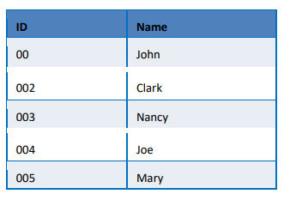

## Write another function named display() which takes 4 arguments. The arguments are named as String and 3 arrays (Employee id, name and salary). Function prototype looks like: display (String name, int regno[], String Empname[], double salary[]).

## This function will search for the name in the Empname array and will display its corresponding id and salary in the below given format. For example, if Divya is given as the name to search then display() function will display the following record.

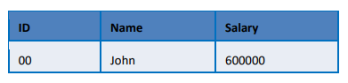

## Note: main() should have the following steps:

## Declaring the arrays.

## Accepting data for the arrays.

## Calling the 2 display() functions which takes 3 and 2 arguments.

## Accept a user name to search in the array and display the record by calling the display() function which takes 4 arguments.

import java.util.Scanner;

public class Main

{

public static void main(String[] args)

{

// declaring the arrays

int[] regno = new int[5];

String[] empName = new String[5];

double[] salary = new double[5];

// accepting data for arrays

inputData(regno, empName, salary);

System.out.println("");

// Q1 output

display(regno, empName, salary);

// Q2 output

display(regno, empName);

// accept name to search

Scanner scanner = new Scanner(System.in);

System.out.print("\n\n\nEnter the name to search: ");

String name = scanner.nextLine();

// Q3 output

display(name, regno, empName, salary);

}

// method to get input from the user

public static void inputData(int[] regno, String[] empName, double[] salary)

{

Scanner scanner = new Scanner(System.in);

for (int i = 0; i < 5; i++)

{

// nextLine() for String and nextInt() for Integer

System.out.print("\nEnter employee id: ");

regno[i] = scanner.nextInt();

// using a dummy nextLine() as nextLine() takes previous line as input after nextInt()

empName[i] = scanner.nextLine();

System.out.print("Enter employee name: ");

empName[i] = scanner.nextLine();

System.out.print("Enter employee salary: ");

salary[i] = scanner.nextDouble();

}

}

public static void display(int[] regno, String[] empName, double[] salary)

{

System.out.println("\n\n3 argument display");

System.out.println("ID\t\tName\t\t\tSalary");

for (int i = 0; i < 5; i++)

{

// using if to adhere to the 3 digit format of id

if (regno[i] < 10)

{

System.out.print("00");

}

else if (regno[i] < 100)

{

System.out.print("0");

}

System.out.println(regno[i] + "\t\t" + empName[i] + "\t\t\t" + salary[i] );

}

}

// overloading display(int[], String[], double[])

public static void display(int[] regno, String[] empName)

{

System.out.println("\n\n2 argument display");

System.out.println("ID\t\tName");

for (int i = 0; i < 5; i++)

{

// using if to adhere to the 3 digit format of id

if (regno[i] < 10)

{

System.out.print("00");

}

else if (regno[i] < 100)

{

System.out.print("0");

}

System.out.println(regno[i] + "\t\t" + empName[i]);

}

}

// overloading display() to search and display

public static void display (String name, int[] regno, String[] empName, double[] salary)

{

System.out.println("\n\n4 argument display");

System.out.println("ID\t\tName\t\t\tSalary");

for (int i = 0; i < 5; i++)

{

if (name.equalsIgnoreCase(empName[i]))

{

if (regno[i] < 10)

{

System.out.print("00");

}

else if (regno[i] < 100)

{

System.out.print("0");

}

System.out.println(regno[i] + "\t\t" + empName[i] + "\t\t\t" + salary[i] );

}

}

}

}

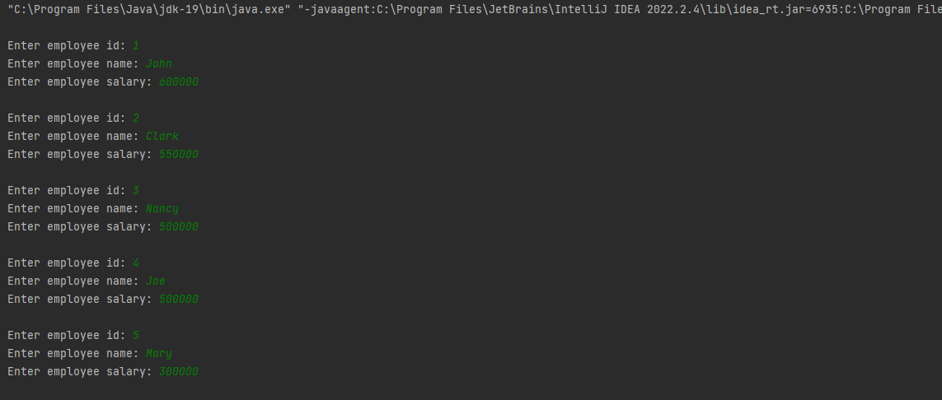

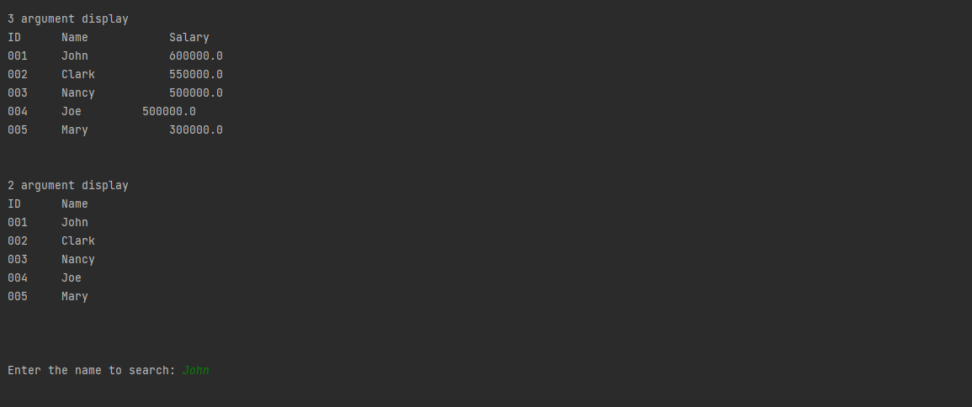

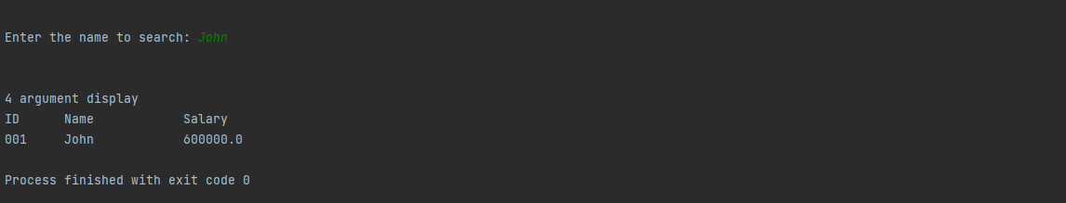

# Case studies

## Case 1, Drinks menu

/*

* Title:

* Case study 1

*

* Description:

* Alex wants an application for his restaurant in which he needs to display the drinks

* available in his restaurant to the customers along with their prizes.

* Create an application which will display the menu items along with the prizes and

* once the order is done, it will calculate the total amount of the order and display it to

* the customers.

*

* Date modified; Author(s); Modification details

* 2022-12-06; abhinna; Created the program

* */

import java.util.Scanner;

public class Case1

{

public static void main(String[] args)

{

// taking scanner for input

Scanner scanner = new Scanner(System.in);

// for infinite loop until exit

boolean loopMenu = true;

// list of menu data

String[] menuNames = {"Coffee", "Tea", "Pepsi", "Coca Cola"};

int[] menuPrices = {50, 25, 50, 55};

int[] quantity = new int[menuNames.length];

DrinksMenu[] drinksMenus = new DrinksMenu[menuNames.length];

for (int i = 0; i < menuNames.length; i++)

{

drinksMenus[i] = new DrinksMenu(menuNames[i], menuPrices[i]);

quantity[i] = 0;

}

// infinite loop for menu

while (loopMenu)

{

// displaying menu items and price

System.out.println("Choose from menu or hit 0 to finalise orders");

System.out.println("SN" + "\t\t\t" + "Item" + "\t\t\t" + "Price");

for (int i = 0; i < menuNames.length; i++)

{

drinksMenus[i].displayMenu(i);

}

// taking order input

System.out.print("Choice: ");

int choice = scanner.nextInt();

for (int i = 0; i < menuNames.length; i++)

{

if (choice - 1 == i)

{

System.out.println("Enter how much of " + drinksMenus[i].name + " do you wish to purchase: ");

quantity[i] = quantity[i] + scanner.nextInt();

}

else if (choice == 0)

{

loopMenu = false;

}

}//for

}//while

// calculating total

double total = 0;

for (int i = 0; i < menuNames.length; i++)

{

total = total + drinksMenus[i].price * quantity[i];

}

// printing the total

System.out.println("The total is: " + total);

}

}

class DrinksMenu

{

String name;

double price;

DrinksMenu()

{

// default constructor required for inheritance

}

DrinksMenu(String name, double price)

{

this.name = name;

this.price = price;

}

public void displayMenu(int i)

{

System.out.println((i + 1) + "\t\t\t" + name + "\t\t\t" + price);

}

}

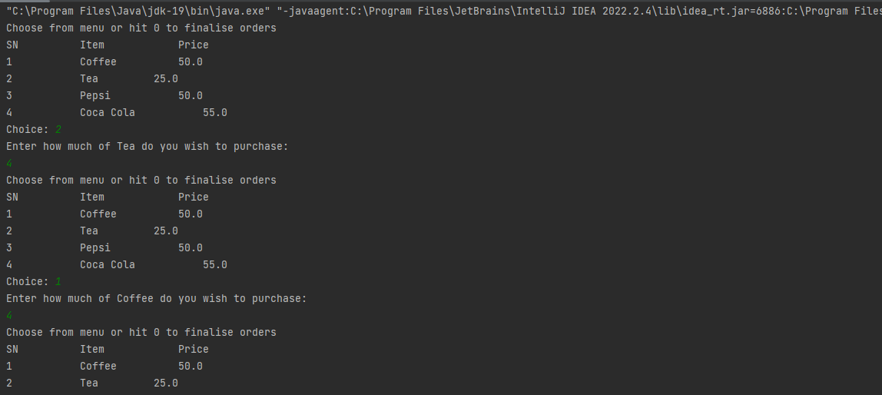

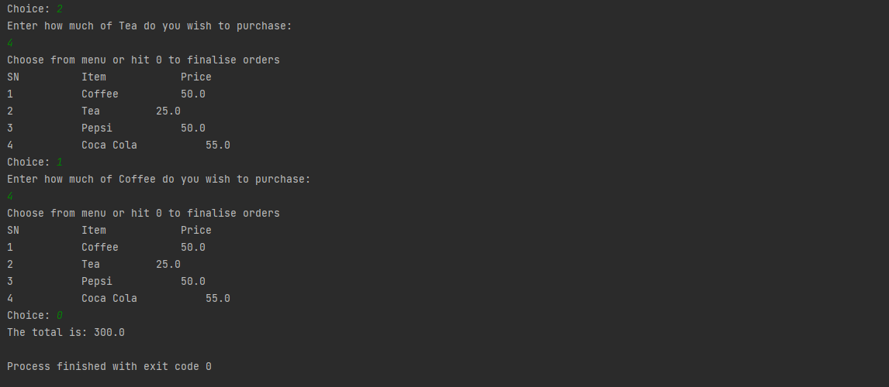

## Case 2, Mobile phone

/*

* Title:

* Case study 2

*

* Description:

* Consider a class named phone which have functionalities like make a call, receive a

* call and messaging.

* Based on this scenario John wants to develop an application which will have class

* named Mobile and methods like dial, receive and message which will

* demonstrate the functioning of these methods.

*

* Use a reference object to call these methods(dial, receive and message and display).

*

* Date modified; Author(s); Modification details

* 2022-12-06; abhinna; Created the program

* 2022-12-08; abhinna; Added body for message and display and implemented them

* */

public class Case2

{

public static void main(String[] args)

{

Mobile m1 = new Mobile("Ram", "9811111111");

Mobile m2 = new Mobile("Shyam", "9822222222");

m1.dial(m2);

m2.message(m1, "I am busy, please call later.");

}

}

class Mobile

{

String name;

String number;

// constructor to define number and name

Mobile(String name, String number)

{

this.name = name;

this.number = number;

}

// dialing another person

public void dial(Mobile mobile)

{

System.out.println("Dialing " + mobile.number + " " + name);

mobile.receive(mobile);

}

// recieving call from someone

public void receive(Mobile mobile)

{

System.out.println(mobile.number + " is calling you " + name);

}

// send message to someone

public void message(Mobile mobile, String msg)

{

System.out.println("\nYou have sent the message " + msg + " to " + mobile.name + ", " + mobile.number);

}

// displaying name and number of self

public void display()

{

System.out.println("\nName: " + name + ", Number: " + number);

}

}

